Career Opportunities for Majors in Genetics and Genomics
Introduction
The Department of Genetics, within the Division of Life Sciences, offers an undergraduate major in Genetics and Genomics that combines a strong foundation in modern genomic science with hands-on research experience. Students participate in original research projects and gain firsthand insight into how scientific discoveries are made.
Coursework covers molecular genetics, genomics, bacterial physiology, and related areas of contemporary genomics. Through laboratory and classroom experiences, students learn to design experiments, apply modern research techniques, analyze and interpret data, and draw evidence-based conclusions. The program also emphasizes scientific communication, preparing students to present their findings through research papers modeled after peer-reviewed publications, as well as presentations and posters suitable for scientific meetings.
The major provides excellent preparation for careers in biological and biomedical research, biotechnology, and the health professions, as well as for advanced study. Most graduates pursue graduate or professional education in fields such as medicine, dentistry, optometry, osteopathic medicine, genetics, genetic counseling, and other health-related disciplines. Others enter research positions in industry, biotechnology companies, government laboratories, or academic institutions.
Every few years, we survey our alumni to learn about their educational and career paths after graduation. The summary below highlights the results of our 2026 alumni survey.

2026 Alumni Survey
Current Graduate School Status* | Count (%)
Completed graduate school | 80 (49%)
Currently enrolled | 44 (27%)
Planning to apply in the future | 24 (15%)
None | 14 (9%)

Highest graduate education attained or currently enrolled | Count (%)
Completed or enrolled: MD, DO, MD/PhD, PhD, DDS, DVM | 41 (25%)
Completed or enrolled: Master of Genetic Counseling | 29 (18%)
Completed or enrolled: Doctor of Biological or Life Sciences | 22 (14%)
Completed or enrolled: Master of Business and Science | 5 (3%)
Completed or enrolled: Other Master’s degree or not reported | 4 (2%)
Completed or enrolled: Master of Public Health | 4 (2%)
Completed or enrolled: Juris Doctor (J.D.) | 3 (2%)
Completed or enrolled: Master of Biotechnology | 2 (1%)
Completed or enrolled: RN/BSN | 2 (1%)
Completed or enrolled: Doctor of Biotechnology/Computational Biology | 1 (1%)
Completed or enrolled: Doctor of Education | 1 (1%)
Completed or enrolled: Doctor of Engineering or other applied science | 1 (1%)
Completed or enrolled: Doctor of Physical Sciences | 1 (1%)
Completed or enrolled: Doctor of Social Sciences | 1 (1%)
Completed or enrolled: Master of Bioethics and Science Policy | 1 (1%)
Completed or enrolled: Master of Biomedical Science | 1 (1%)
Completed or enrolled: Master of Business Administration | 1 (1%)
Completed or enrolled: Master of Counseling Psychology | 1 (1%)
Completed or enrolled: Master of Education | 1 (1%)
Completed or enrolled: Master of Medical and Clinical Science | 1 (1%)
Completed or enrolled: Master of Physician Assistant | 1 (1%)
Completed or enrolled: Master of Science in Health Informatics | 1 (1%)
Completed or enrolled: Other doctoral degree | 1 (1%)

Future graduate education | Count (%)
Not planning to attend graduate school | 14 (9%)
Future: MD, DO, MD/PhD, PhD, DDS, DVM | 7 (4%)
Future: Master of Genetic Counseling | 4 (2%)
Future: Master of Business Administration | 4 (2%)
Future: Doctor of Biological or Life Sciences | 2 (1%)
Future: Juris Doctor (J.D.) | 2 (1%)
Future: Undecided | 2 (1%)
Future: Master of Business and Science | 1 (1%)

Industry currently employed | Count (%)
Healthcare (e.g., medicine, dentistry, veterinary, and genetic counseling) | 71 (44%)
Biotech/Pharmaceutical | 26 (16%)
Graduate Student | 24 (15%)
Research/Science | 8 (5%)
Not Employed | 5 (3%)
Education: Higher Education (public or private) | 5 (3%)
Government & Public Administration | 4 (2%)
Education: Elementary, Secondary, or adult education | 3 (2%)
Financial Services | 3 (2%)
Law/Legal Services | 3 (2%)
Computer Science, Technology, Information Technology | 2 (1%)
Medical Technology | 1 (1%)
Business & Healthcare services | 1 (1%)
Retail/Wholesale trade | 1 (1%)
Social Sciences | 1 (1%)

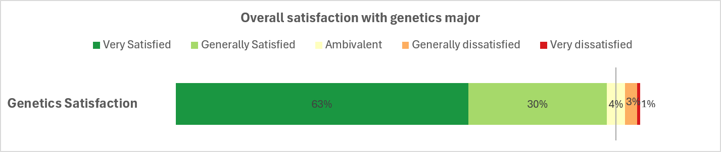

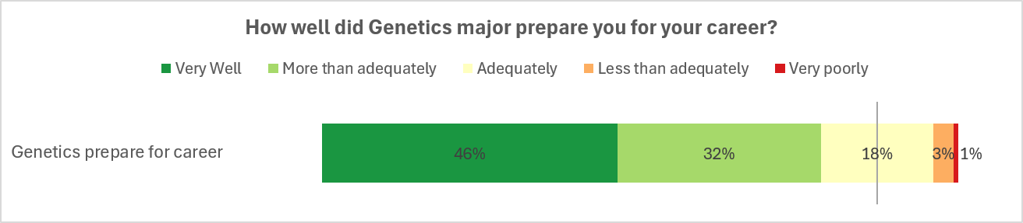
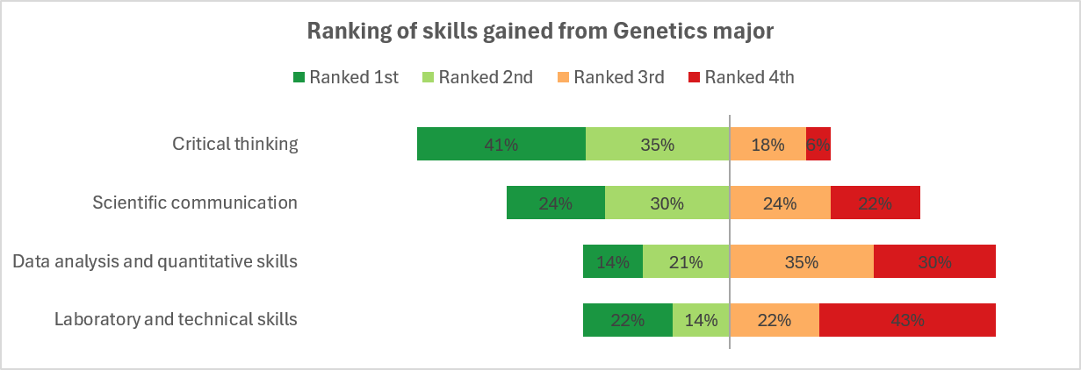

What would you tell a prospective student or parent about majoring in Genetics and Genomics?
Genetics is an evolving field and is increasingly relevant to a number of industries, including medicine and biotech. A genetics major positions you well to explore a multitude of career paths and is foundational to a higher degree in any of these pursuits. My genetics major allowed me to not only learn more about the career I ultimately chose (genetic counseling) but provided me with the prerequisites I needed to not just qualify for graduate school, but to also succeed.
It was a wonderful experience, it opened opportunities to research which ultimately allowed me to see that medicine was what suited me the most and the course work I did helped me prepare for the MCAT and ultimately helped with my medical courses in medical school.
It is a very small and tight nit major, which I appreciated. The smaller class sizes allow you to get to know your classmates and your professors. The career panels were helpful to think about what you can do with your degree.
There are a lot of transferable skills to many different industries. The opportunity to do undergraduate research will set you up for success in ways that go beyond just the technical skills (which are also very valuable!). You’ll get skills that will get you in the door and skills that will help you build a career.
Helps you learn how to think. Helps you realize that there’s more that we don’t know in life, not everything can be found textbook
Genetics is a great major that prepares the student for any future advanced scientific training and career.
It was the best decision I made during my undergraduate career! The faculty are incredible, I learned a ton about a quickly developing and highly relevant field, and I was extremely well prepared for graduate school.
I think the Genetics program at Rutgers was phenomenal. The overall university experience at Rutgers varies.
Choosing the genetics major at Rutgers was the best decision I ever made. Take advantage of all of the courses they have to offer and get involved in research as soon as you can!
Genetics opens up a lot of career paths and connections. You can go into research (PhD), medical school, pharmaceuticals, genetic counseling, or a science-adjacent field like scientific journalism, marketing/business for a medical company; etc. The professors and staff are very engaged and easy to collaborate with. I felt very supported as a Genetics major and it was a great experience.
I was a unique kid in that I've known since I was 16 that I wanted to study genetics and cancer. Rutgers genetics degree was one of the only options that gave me the opportunity to become and expert in this field in my first degree. Throughout this degree you have the opportunity to get a lot of 1 on 1 attention from the incredible professors because of the small class size, which also helps to make Rutgers smaller, in the best way. The degree is also arranged so that every student has many options of what to do after, and they're prepared for all possibilities, whether that's going to medical school, pursuing a graduate degree, or going into the industry.
Beyond just the really cool science you are exposed to and participate in, you will learn a lot about yourself and be set for your career long term. The rigor of this program is equitable to extremely high level career roles
Great major - more specialized than the typical biology degree. Genetics is really the future of medicine.
If you want to do life science as a career the Rutgers undergraduate Genetics major is a fantastic choice. It set me up to succeed and do well in grad school and my current industry role. Make sure that you join a lab in your Sophomore year though, the lab research experience is the most important part and it will let you apply the things you learn in class.
The Genetics program at Rutgers was incredibly unique because it took a step away from multiple-choice-based testing and instead forced us to create thoughtful explanations for experimental design and outcomes. The mandatory research component also developed students' resumes and prepared us for research environments outside of the university. I highly recommend it to any student interested in a career in research, who wants to get their hands wet in the lab.
Amazing professors, good research opportunities, really interesting coursework
I would tell a prospective student that genetics, beyond the science itself, builds your ability to think critically and look beyond what's immediately apparent. The courses are designed to teach you to see the bigger picture, for example, examining parental history to understand how genetic traits are inherited and expressed. That kind of reasoning grows into the complex, layered thinking that helps people succeed well beyond the classroom. For me, genetics built exactly this skill and helped fast-track my journey to where I am today.
Majoring in genetics has been a great experience overall. It has prepare some for many different aspects of my work even though it isn't research or even immediately related to the field of genetics. At Rutgers, the skills you learn from the staff and courses are invaluable. The faculty and staff are nice and wonderful to work with. The critical thinking skills, computer programming, day analysis, and communication skills learned are applicable to any field and have helped me greatly succeed in my path to law school.
Genetics is a rapidly growing and exciting field! There are so many paths a degree in genetics can lead you down, and I think the path from degree to career is more direct compared to some other life science degrees. I would encourage anyone with an interest in healthcare or the life sciences to consider majoring in genetics.
Majoring in genetics opens the door to many fields and allows students to attain a high level of understanding about biology and chemistry, possibly higher than in a more general major in which courses are more variable and don’t build on previously learned knowledge. As a medical student, having majored in genetics has given me a significant advantage in that I was already familiar with congenital diseases and cancer genetics at the beginning of my graduate education.
The Rutgers Genetics department is world class research with a neighborly feel. This department will teach you not only to do great science, but also be a great scientist.
The requirements for the genetics major, specifically the research, was extremely helpful for me down the road. The genetics faculty members enjoy working with students and are a great resource.
Wonderful degree with small class sizes, personalized attention from advisors, and a lot of flexibility to customize a life sciences major to fit your academic and research interests
The Genetics department at Rutgers is extremely supportive and encouraging to their students. The professors are truly wonderful, enthusiastic, and passionate about their science as well as engaging with the students. Rutgers is an enormous school where you learn to fend for yourself and take opportunities that come to you. As a student in Genetics I found the community helpful in both pushing their students to accomplish their goals and encouraging to ask questions and receive help. I enjoyed my time in the department.
The flexibility and depth of the material learned in the genetics major sets it apart from any other life sciences major. Anybody considering a graduate degree should be seriously considering the genetics major as it provides a fantastic background and experience to make it in the next level.
Majoring in genetics was awesome for a pre-medical student as it qualifies all the prerequisites and gave me so much research experience. I gained lots of extra helpful background knowledge through electives and loved the small classroom sizes.
It opens up a variety of lines for a student to pursue. For example, you can go into academia, medicine, genetic counseling, or even industry. Genetics is becoming a very important topic in medicine, and there is a lot of further scope in this field of study.
Great major if you are interested in pre-med or research. The faculty are super nice and they give great advice and are very approachable. There are very interesting classes that dive into specific topics of genetics and prepare you for research and critical thinking.
I'd tell them it's a major that adequately prepares you to participate in genetic research and provides you with high quality training. It's a major that has a strong emphasis on scientific communication and thorough understanding of the science.
I referred many pre-med students because the wet lab training and research topic is great to speak about during interviews. The subject knowledge of genetics is very relevant to all medical students.
It was an excellent major with many resources. I felt extremely supported as an undergraduate which can be difficult at a large university.
Rapidly advancing field, directly appliable to many aspects of medicine, exposure to research, variety of career paths
The field is ever expanding and is not limited to one career path. There are so many avenues to explore with genetics and its constant evolution makes it so interesting.
It is an excellent program with supportive faculty. Prepares you very well for medical school.
Unique degree that gives more opportunities than other biological degrees
That passion for genetics should be a factor in the decision to pursue this major & to keep an open mind regarding future jobs. I did not know which job(s) I would pursue, but knew that I was passionate about genetics. I learned about the field of genetic counseling during my undergraduate degree, and am now a genetic counselor thanks to the Genetic Counseling Certificate Program. The major would adequately prepare any prospective genetic counselor for graduate school, as well as others passionate about other careers in Genetics.
I would tell them that a degree in Genetics opens a world of opportunity. I would also encourage them to pursue a Masters or PhD in the field, in order to better leverage skills.
It's a challenging major and it sets you head-and-shoulders above your peers in feeling prepared and capable for the workforce.
Despite many professions being replaced with the use of AI, there are still many jobs available in biomedical or pharmaceutical sciences to geneticists. Having a genetics undergraduate education instead of a biology degree can help make your application for a job or graduate program more competitive.
Supportive faculty, interesting electives, opportunities for research.
Genetics is a versatile field with opportunities across many disciplines, offering a wide range of career paths.
The major exposes you to many different subfields involving genetics and will teach the skills needed for the job force/graduate education. There is a big emphasis on research, which will be beneficial for post-graduation.
It provided me with the skills and experiences the prepared me for my current job.
If you are interested in genetics, and particularly research, the genetics major is a great option. It is a relatively small cohort, which fosters a community of students. And the professors and contents are interesting.
The major at Rutgers is very research-based and prepares you well for a career in/around research. Initially it might seem like one needs an additional, advanced degree to qualify for a job in genetics, but there are jobs in the field requiring just the bachelor’s degree.
It’s a great program that prepares you for grad school in genetics/medicine.
The field is expanding rapidly and there's so much to study and learn - it's hard to get a job in academia but it's worthwhile to be able to contribute to medical research and the field itself makes you an eternal student. There's always something new to learn.
Focus on critically thinking through the assignments. Network and seek advice from professors as well as pay attention in intro to courses to gauge what attracts you. Genetics is a vast field and intro courses give a good ground work for all the different applications and subfields.
NETWORK. Talk to more than just your research mentor. I got opportunities after undergrad because people remembered me and my interests. Do the social events. Go to as many talks and dissertations as you can. You might not understand or be good at asking questions but the exposure is important. Lastly, LEARN TO PRESENT WELL. It will be crucial for any scientific or medical career you choose (or any career really). It is the most important skill I learned.
Finding a lab to join might take a decent amount of effort, but it was well worth the effort and start trying to join a lab as early as possible
One of the biggest benefits of the major is the requirement for undergraduate study, which ensures all undergrads gain hands on experience in a lab.
I loved the degree, don’t use it very often but it was interesting to study while also getting my premed requirements out of the way
Can open doors and a conversation better than other similar majors.
I really enjoyed taking Genetics during undergrad and it’s a major that is represented well if pursuing a path in medicine or Genetics related. However, I had a change in my career path, hence, why it is not as relevant. It’s a very rigorous major, but one that was meaningful during my time there.
It provides you with a solid foundation for medical school.
It’s a unique program that can open you to future careers

