Filling out your Research Form with DocuSign
PLEASE MAKE SURE YOUR ADVISOR HAS APPROVED YOUR SUMMARY PRIOR TO FILLING OUT THIS FORM. IF CORRECTIONS ARE NEEDED, THE FORM WILL BE VOIDED AND YOU WILL HAVE TO RESUBMIT THE ENTIRE THING.
You will write your approach summary in a separate document and upload it to the form as indicated.
INSTRUCTIONS
1. Click the link to the correct form on the Independent Scholarship Forms page.
- If your research mentor is a Genetics Faculty Member, use the “Genetics Faculty Mentor form.”
- If your research mentor is OUTSIDE the Genetics Department, use the “Non-Genetics Faculty Mentor form.”
- If you are planning to do an honors thesis, use the “Honors Thesis form.”
- If you are planning to do an Advanced Independent Study, Writing Intensive, or summer research, use the “Independent Study, Writing Intensive, and Summer form.”
- If you are only registering for Effective Communications course, use the “Effective Communication Only form.”
2. Enter your name and email, and your mentor’s name and email to route the form correctly. Program Coordinator and Vice Chair will automatically fill in. Click Begin Signing.
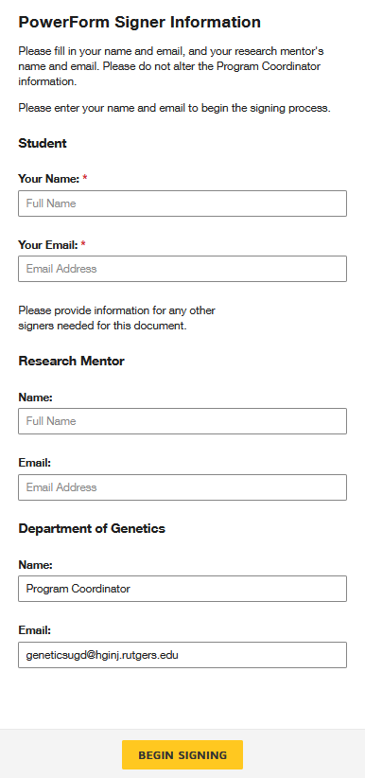

3. The research form is the same as the paper form. All fields highlighted in red are mandatory. Under Approach to be Used, you will click the yellow button to upload your research summary. The upload will be added as an additional page to the end of this document.
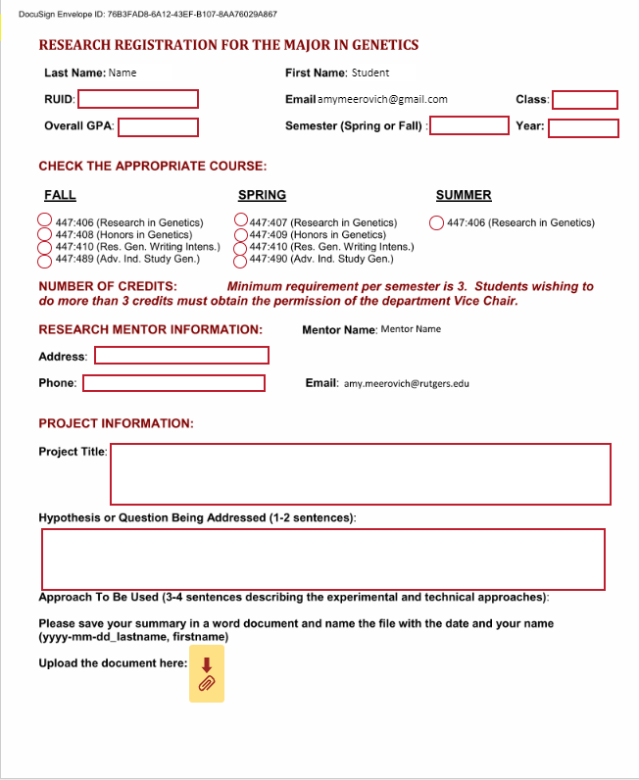
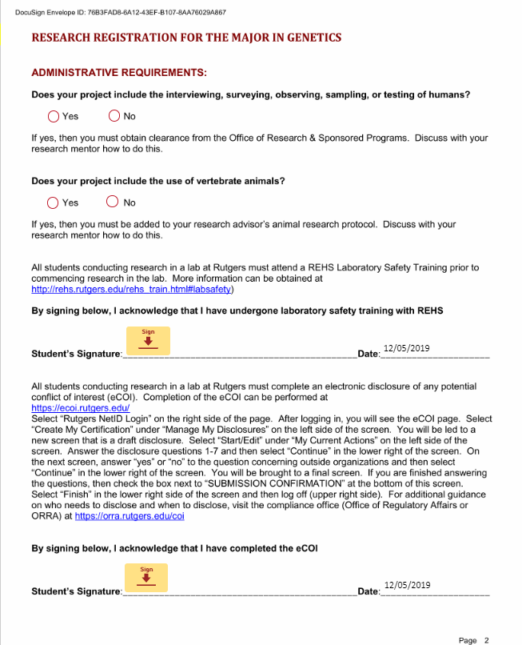
4. You will click on the first yellow button to sign the form. You will see a pop-up to let you choose your digital signature. Click Adopt and Sign. All subsequent signatures will fill in when you click the yellow boxes.

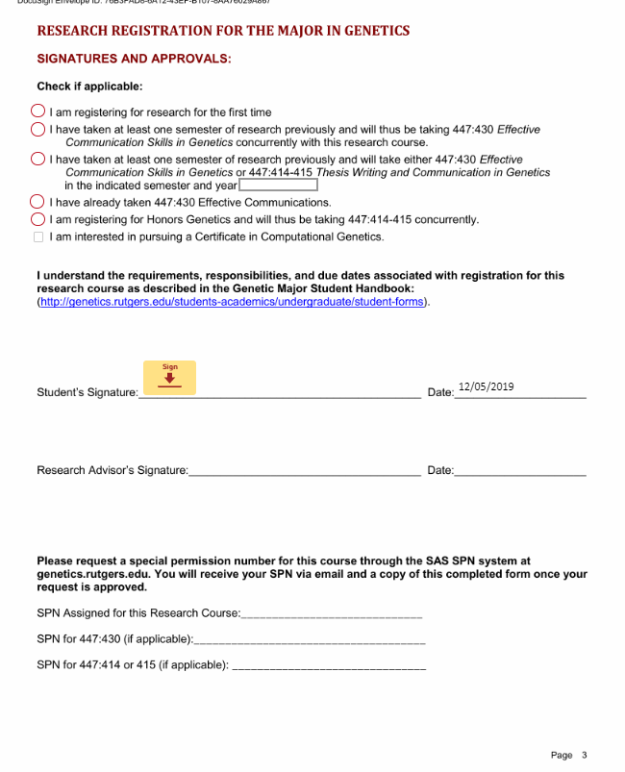
5. Once you have signed in all of the required spaces, click Finish.
6. The form will now be routed to your research mentor for a signature. Once it is completed and signed, it will be sent to the program coordinator to issue an SPN. You will receive the SPN in a separate email generated from the SAS SPN system. You will receive a separate email for each course requested. The SPNs will also be added to the form and you will receive a copy.

